Predicting Wine Quality
2017 Machine Learning Term Project

YunMin Cho
Computer Engineering
Kyung Hee Univ.
Yongin, Korea
dbsals0618@naver.com

Abstract—This Machine Learning Project is Predicting Wine Quality. Data set for this project is Wine Quality Data Set from UCI Machine Learning Repository. It has 12 attributes, and 12th attribute is wine quality. The goal of these machine learning project is to classify wine quality. I used logistic regression for multinomial classification. I trained Multi Layer Perceptrons(MLP) which is fully connected, feedforward networks. To minimize error cost I used Gradient Descent Optimizer at first, but later I used Adam Optimizer for better result. After running this project, there will be 3 classes(bad, normal, good) of wine quality. I used Tensorflow as machine learning tool which is open source library made by Google for machine learning and deep learning.
Keywords—predicting wine quality; classification; multinomial classification; adam optimizer; hypothesis; machine learning; training;

Introduction

How do people know wine quality? In the past, only wine connoisseurs could evaluate the quality. So there were many differences in price and quality of wine, but no one could explain the reason why they are different except for the wine connoisseurs. However, in the late 1900s, Orley Clark Ashenfelter who is a professor of economics at Princeton University predicted relationship between wine quality and weather through analyzing several decades of data sets. The formula is given below:
Formula1. Ashenfelter’s predicting wine quality formula

He was criticized by people at that time, but it was proved later that the formula is right. Using this formula, We can predict wine quality not depending sense of wine connoisseurs.
However, this method is not solely based on the information of wine. The weather information of the environment where grapes were cultivated is positively necessary. Then is it impossible to predict the quality just using the information of wine?
This machine learning project predicts wine quality only using the information of wine. The data set used in this project is Wine Quality Data Set from UCI Machine Learning Repository. This data set has 12 attributes, and 12th attribute is wine quality(score between 0 to 10). To classify this data set into 11 stages, I had to do multi-class classification. The main idea of this project is given below.
- I use Tensorflow as machine learning tool which is open source library made by Google for machine learning and deep learning, and it based on Python.
- The data set file extension is CSV, and I did data normalization.
- There are many hidden layers and hidden nodes for deep learning.
- I used Sigmoid function as activation function, and also used softmax function at last layer.
- I used AdomOptimizer as optimization function to minimize the cost function.

Prepareing data set

About Data Set

Table 1. Information about Wine Quality Data Set
Data Set Characteristics: | Multivariate | Number of Instances: | 4898 | Area: | Business
Attribute Characteristics: | Real | Number of attributes: | 12 | Date Donated: | 2009-10-07
Associated Tasks: | Classification, Regression | Missing Values? | N/A | Number of Web Hits: | 525588

The Data Set of this project is Wine Quality Data Set. Information about data set is like table 1. There are 12 attributes, and here are the list.
- Fixed acidity
- Volatile acidity
- Citric acid
- Residual sugar
- Chlorides
- Free sulfur dioxide
- Total sulfur dioxide
- Density
- pH
- Sulphates
- Alcohol
- Quality

12th attribute is wine quality(score between 0 and 10), and the goal of this machine learning project is to predict wine qualities. But I reduced the scope of a problem because of the better result. Original wine quality data which is 12th attribute was 0 ~ 10 ranges. I defined 3 scores(bad, normal, good). Normal is 6, and bad is smaller than 6. Good is bigger than 6.
Except quality, all attributes in the list are related to information about wine, not a brand of wine or price of wine. So after this project, we can predict wine quality only using information about wine.

Data Preprocessing
Original data set is irregular in scope. Some attributes are smaller than 1, and some attributes are bigger than 100. So data preprocessing must have done. Because machine learning algorithms learn from data, it is critical to prepare the right data for the given problem.
Many machine learning algorithms prefer normalized values (0 ~ 1), so I did. There are two versions of data feature scaling, normalization and standardization. Data normalization is used to bring all values into the range [0, 1]. Data normalization formula is given below:
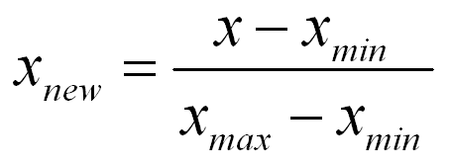
Formula2. Data normalization
Data standardization transforms data set to have zero mean and unit variance. Its formula is given below:
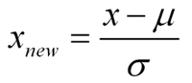
Formula3. Data standardization
All attributes except ‘quality’ are input data called ‘x_data’. Quality which is 12th attribute is called ‘y_data’. In this project, I used data normalization, not a standardization. After normalization, all values of x_data are into the range [0, 1]. For better result, the scope of y_data should be reduced. So I changed y_data. I defined 3 scores(bad, normal, good), bad is 0, normal is 1, and good is 2. In case original y_data was smaller than 6, it changed 0, otherwise it changed 2 if original y_data is bigger than 6. It changed 1 if original y_data is 6.

Machine learning (data training)

Multilayer Perceptron
Because I have 3 classes(bad, normal, good), I have to do multinomial classification. Multinomial classification is the problem of classifying instances into one of three or more classes. So I trained my machine learning project with multilayer perceptron. A multilayer perceptron(MLP) is a class of feedforward artificial neural network. Multilayer perceptron consists of at least three layers (an input and an output layer with one or more hidden layers). No matter how many hidden layers it has. There are no rules. So I put 3 hidden layers between input layer and output layer. I tried from 1 to 13 hidden layers, I think 3 hidden layers show the best result. Also, no matter how many hidden nodes it has. But it should have 11 input nodes because the data set has 11 attributes except quality. It also should have 3 output nodes because there are three classes as output.
…
11 input nodes
3 output nodes
3 hidden layers

Fig1. Multilayer perceptron

Activation Function
In computational networks, the activation function of a node defines the output of that node given an input or set of inputs. Because I had 3 classes as output, I had to use non-linear function. A representative activation function is sigmoid function which is non-linear function. Its formula is given below:
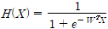
Formula4. Sigmoid function
There is an another representative activation function, called softmax function. Sigmoid function is usually used for the two-class logistic regression, whereas the softmax function is used for the multiclass logistic regression. So I used softmax function at output layer(last layer), and I used sigmoid function at other layers. Sigmoid function and softmax function is provided by tensorflow.

Training
To train the model, I made hypothesis for it and softmax function was used here. Formula of hypothesis looks like this:
Formula5. Hypothesis

Then, cost function is needed to train the model. Because I had to do multinomial classification, I used cost function like below:
Formula6 Cost function

After setting cost function, I used Adam Optimizer as optimization function. Optimization function is needed to minimize the cost function. At first I used Gradient Descent Optimizer, but I changed it to Adam Optimizer for better result. Adam Optimizer is an optimization algorithm that can used instead of the classical stochastic gradient descent procedure to update network weights iterative based in training data. So I used this algorithm. Optimization function is provided by tensorflow.
Finally, I set learning rate and training epoch. Because it affects the training result, I tried learning rate from 0.0000001 to 0.1 and training epoch from 10 to 20000. I chose my final learning rate to 0.001, and training epoch to 70. My final training set is like Table2.
Table2. Multilayer Perceptron Training Set
Number of hidden layers | 3
Activation function | Sigmoid / Softmax(only output layer)
Optimization function | Adam Optimizer
Learning rate | 0.001
Training epoch | 70

Conclusion
At first, I thought this project was quite easy to train. But It was wrong. My first prediction accuracy was 0.02. So I tried to find the best combination to train my machine learning project.

My Project Conclusion
I used tensor board to visualize my project structure and result. Main Graph of my machine learning project is like below:.
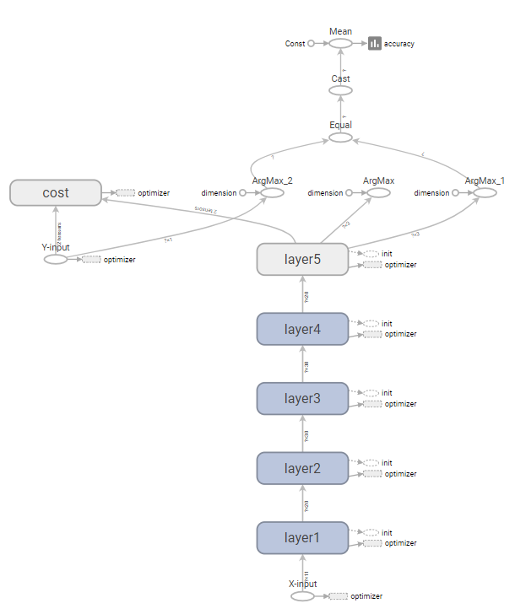
Fig2. Main Graph

My final result of this machine learning project, the accuracy is 0.679665. Actually, this isn’t a great score. However, my first result was 0.02 and my worst result was 0.007. I think there were too many classes to classify because there was 11 classes at first. So I defined 3 classes to simplify the problem. And I also changed data preprocessing method from data standardization to data normalization. Finally I got 0.679665 as a result. Fig3 is my cost function graph and fig4 is my final accuracy.
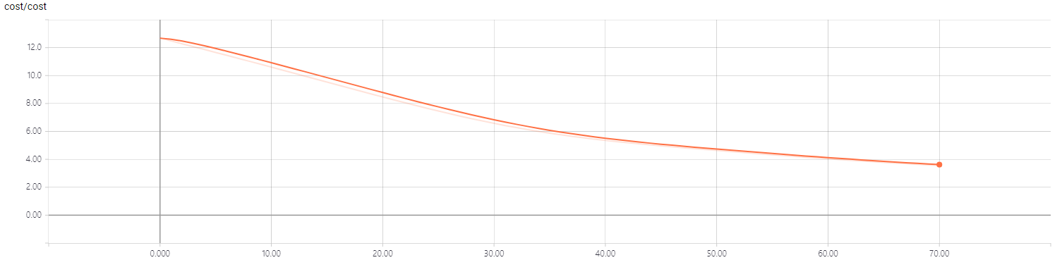
Fig3. Cost function graph

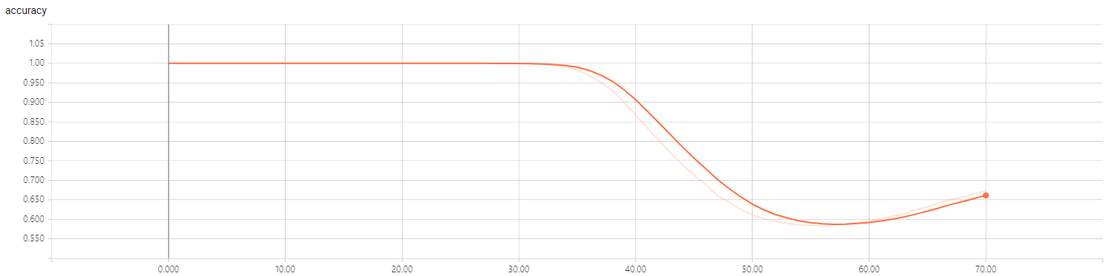
Fig4. Accuracy graph

Test Data Set
I have two data sets. One is data set of white wine, another is data set of red wine. But there are no differences the two. So I used the first one for training, another one for testing. Data set of white wine has 4898 instances, and data set of red wine has 1599 instances.
I did data normalization same as training data set. And I also defined 3 classes as output. Then I got 0.628518 as accuracy. It is very similar with training result. So I think the result shows that this project is quite successful.

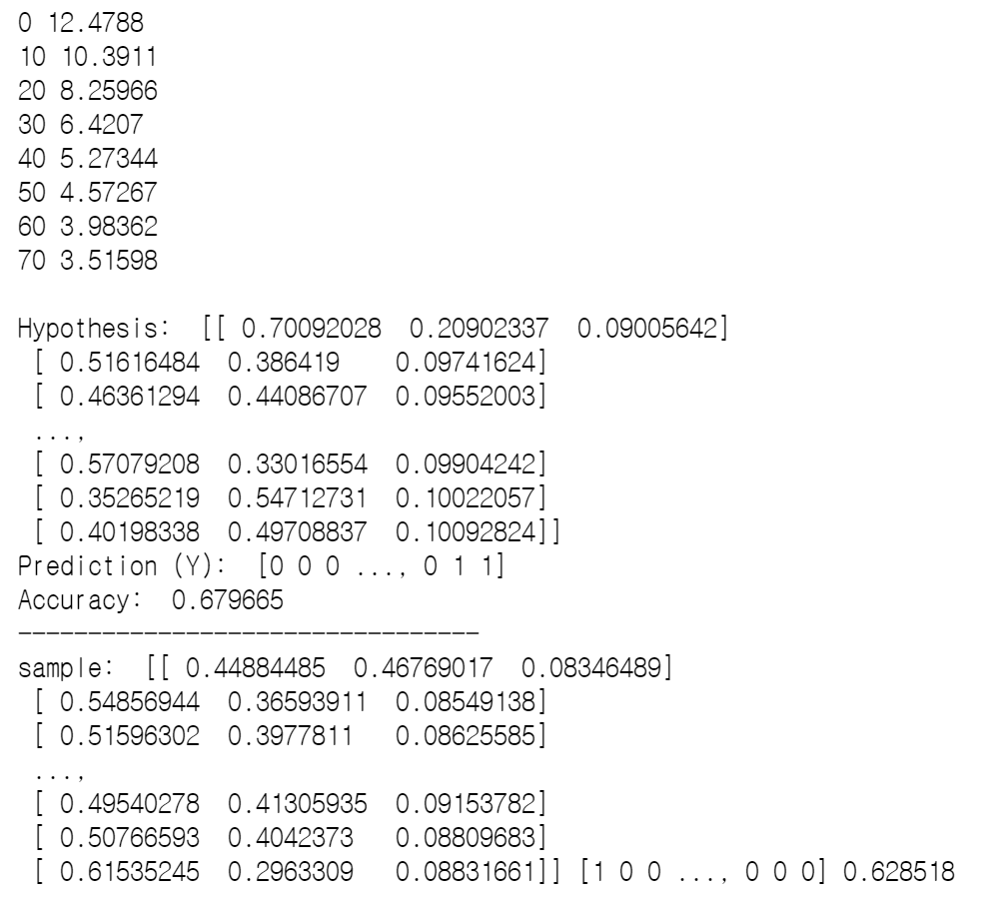
Fig5. The result of this project

Related Preceding Research
There are many preceding researches about predicting wine quality. I found out that there was a worldwide machine learning contest at 2011, and its topic was predicting wine quality. The name of contest is Cheers! Predicting Wine Quality. The data set this contest used is exactly same as mine. Fig3 is the result of the contest.
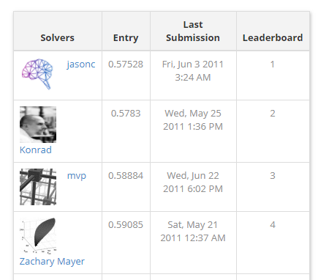
Fig5.The result of <Cheers! Predicting Wine Quality> contest

References
- 정성원(2015.03) “빅데이터 분석의 가치창출” http://www.bigdata.go.kr/data/pdf/issue_2015_3.pdf
- “UCI Machine learning Repository” http://archive.ics.uci.edu/ml/datasets/Wine+Quality
- Seok Lim (2016.07.17) “normalization” RH http://gtolarc.logdown.com/posts/773748
- Sandro Saitta (2007.07.10) “Standardization vs. normalization” Data Mining Research http://www.dataminingblog.com/standardization-vs-normalization/
- Teja Kodali (2016.02.04) “Predicting wine quality using Random Forests” R-bloggers https://www.r-bloggers.com/predicting-wine-quality-using-random-forests/
- “Activation function” WIKIPEDIA https://en.wikipedia.org/wiki/Activation_function
- Jason Brownlee (2017.07.03) “Gentle Introduction to the Adam Optimization Algorithm for Deep Learning” MACHINE LEARNING MASTERY https://machinelearningmastery.com/adam-optimization-algorithm-for-deep-learning/
- “Cheers! Predicting Wine Quality” CrowdANALYTIX https://www.crowdanalytix.com/contests/cheers-predict-wine-quality/

This project code is here

